Gram schmidt Factorisation

FUNCTION : GRAM-SCHMIDT ORTHOGONALIZATION

Purpose: This function implements the Gram-Schmidt orthogonalization process, which transforms a set of linearly independent vectors (columns of matrix A) into an orthonormal basis (stored in matrix Q).
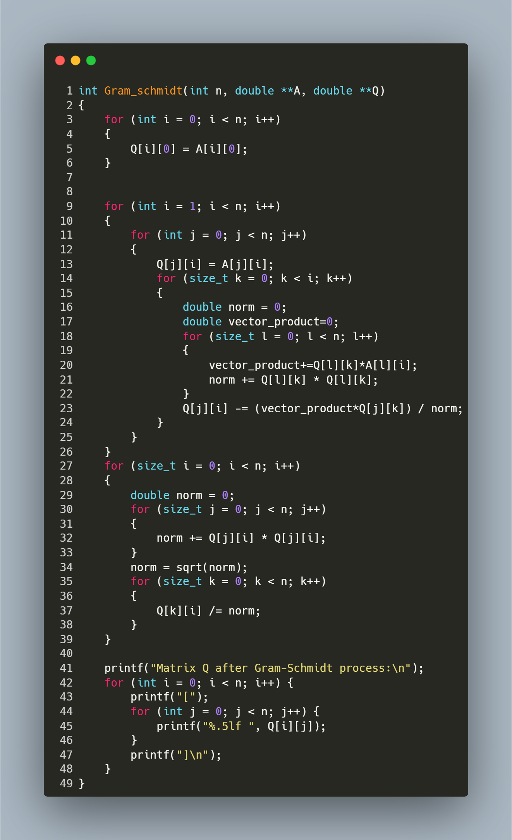

Step-by-Step Explanation:
- First Vector Initialization:
  - The function copies the first column of matrix A directly to matrix Q.
  - Q[i] = A[i]; for all rows i from 0 to n-1.
- Orthogonalization Process:
  - The outer loop for (int i = 1; i < n; i++) iterates through each column of A starting from the second column.
  - For each column i:
    - Initially copies column i from A to Q: Q[j][i] = A[j][i];
    - For each previously processed column k (0 to i-1):
      - Calculates the dot product between column k of Q and column i of A: vector_product+=Q[l][k]*A[l][i];
      - Calculates the squared norm of column k of Q: norm += Q[l][k] * Q[l][k];
      - Subtracts the projection of column i onto column k: Q[j][i] -= (vector_product*Q[j][k]) / norm;
    - This makes column i orthogonal to all previous columns.
- Normalization:
  - After all columns are orthogonalized, each column is normalized to have unit length.
  - For each column i:
    - Calculates the Euclidean norm: norm = sqrt(norm);
    - Divides each element by the norm: Q[k][i] /= norm;
    - This transforms orthogonal vectors into orthonormal vectors.
- Result Output:
  - The function prints the resulting orthonormal matrix Q.
  - Each row is displayed in bracket notation with values formatted to 5 decimal places.

Function: Backward Substitution for Solving Upper Triangular Systems

Purpose: This function solves a system of linear equations Ux = b, where U is an upper triangular matrix.
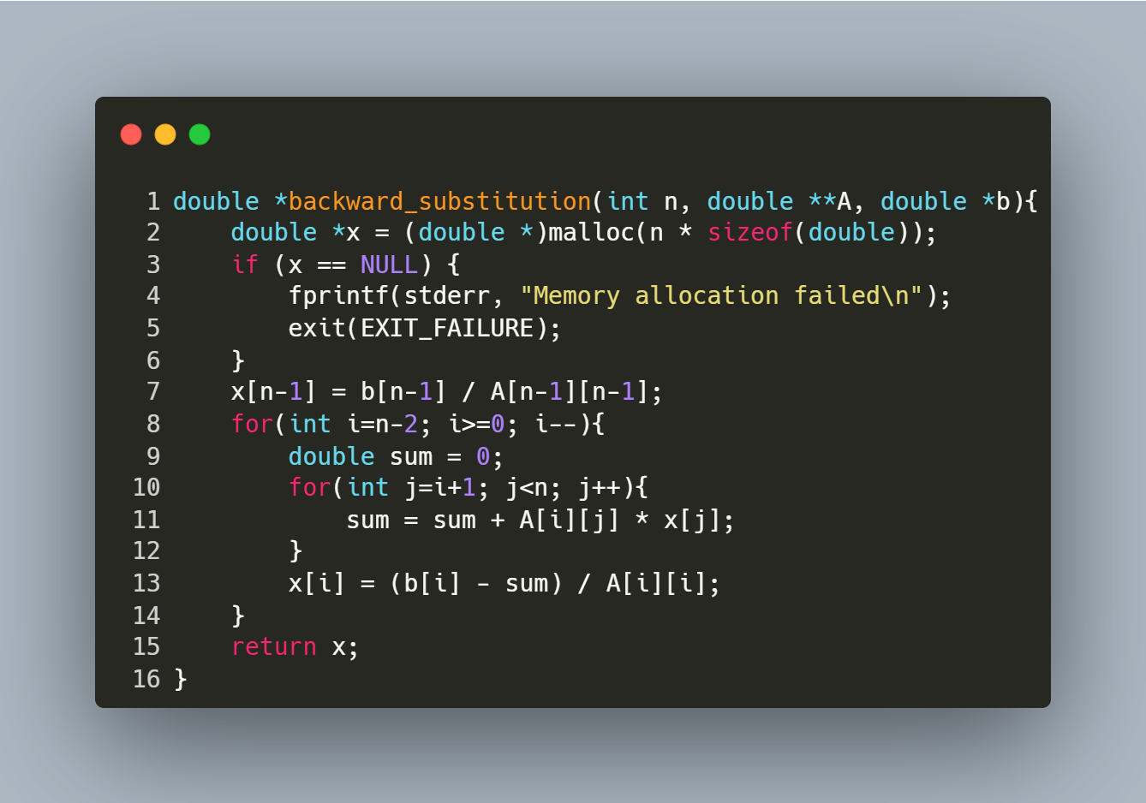
Step-by-Step Explanation
- Memory Allocation:
  - double *x = (double *)malloc(n * sizeof(double));
Allocates memory for the solution vector x.
  - Checks for allocation failure and exits if memory is unavailable.
- Initialize Last Element:
  - x[n-1] = b[n-1] / A[n-1][n-1];
Solves for the last variable directly using the bottom row of the upper triangular matrix U.
- Backward Substitution Loop:
  - for(int i=n-2; i>=0; i--)
Iterates from the second-last row to the first row.
  - double sum = 0;
Initializes a sum to accumulate contributions from already solved variables.
  - for(int j=i+1; j<n; j++)
Sums the products of coefficients (A[i][j]) and known solutions (x[j]).
  - x[i] = (b[i] - sum) / A[i][i];
Computes the current variable x[i] by subtracting the accumulated sum from b[i] and dividing by the diagonal element A[i][i].
- Return Result:
  - Returns the solution vector x, which satisfies Ux = b.

FUNction : Matrix Transposition

Purpose: This function transposes a square matrix of size n x n
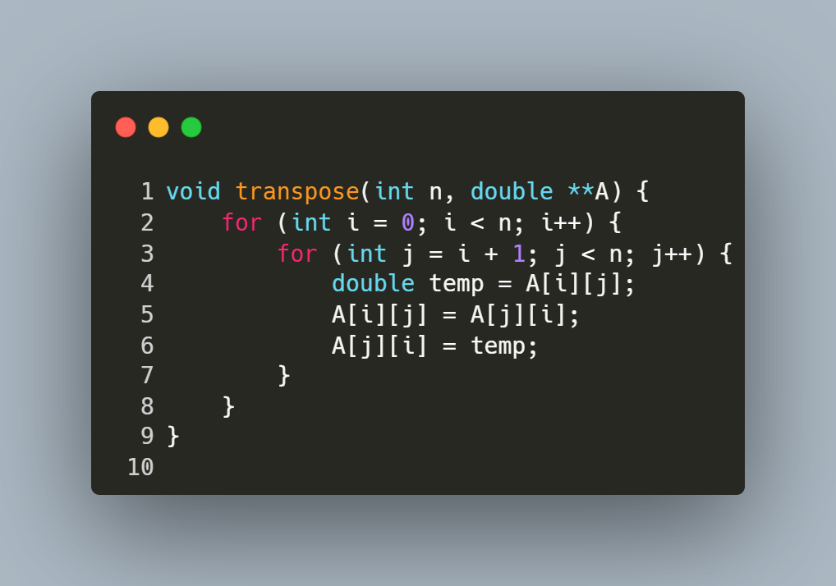
Step-by-Step Explanation
- Outer Loop (i from 0 to n-1):
  - Iterates over each row of the matrix.
- Inner Loop (j from i+1 to n-1):
  - For each row i, iterates over columns starting from i+1 (avoids redundant swaps on the diagonal and below).
- Swap Elements:
  - Swaps A[i][j] (element above the diagonal) with A[j][i] (element below the diagonal).
  - Example: For i=0 and j=1, A and A are swapped.
- Result:
  - After all iterations, the original matrix A becomes its transpose.

Function : Matrix Multiplication for Square Matrices

Purpose: This function multiplies two square matrices A and B of size n x n and stores the result in matrix C.
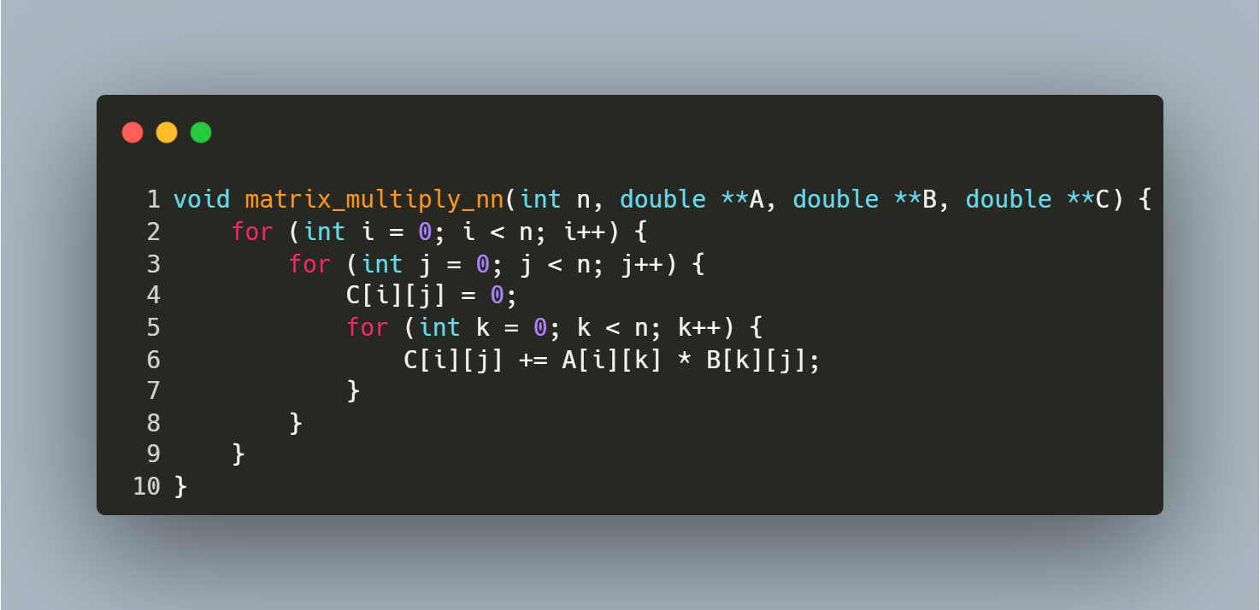
Step-by-Step Explanation
- Initialization:
  - The outer loop for (int i = 0; i < n; i++) iterates over each row of matrix A.
- Column Iteration:
  - The middle loop for (int j = 0; j < n; j++) iterates over each column of matrix B.
- Dot Product Calculation:
  - C[i][j] = 0; initializes the element at row i, column j of matrix C to zero.
  - The inner loop for (int k = 0; k < n; k++) computes the dot product of the i-th row of A and the j-th column of B:
    - C[i][j] += A[i][k] * B[k][j]; accumulates the product of corresponding elements.
- Result Storage:
  - After completing all iterations, matrix C contains the product of A and B.

Function : Matrix-Vector Multiplication

Purpose: This function multiplies a square matrix A of size n x n with a vector B of size n and stores the result in vector C. It computes the dot product of each row of A with B to produce C.
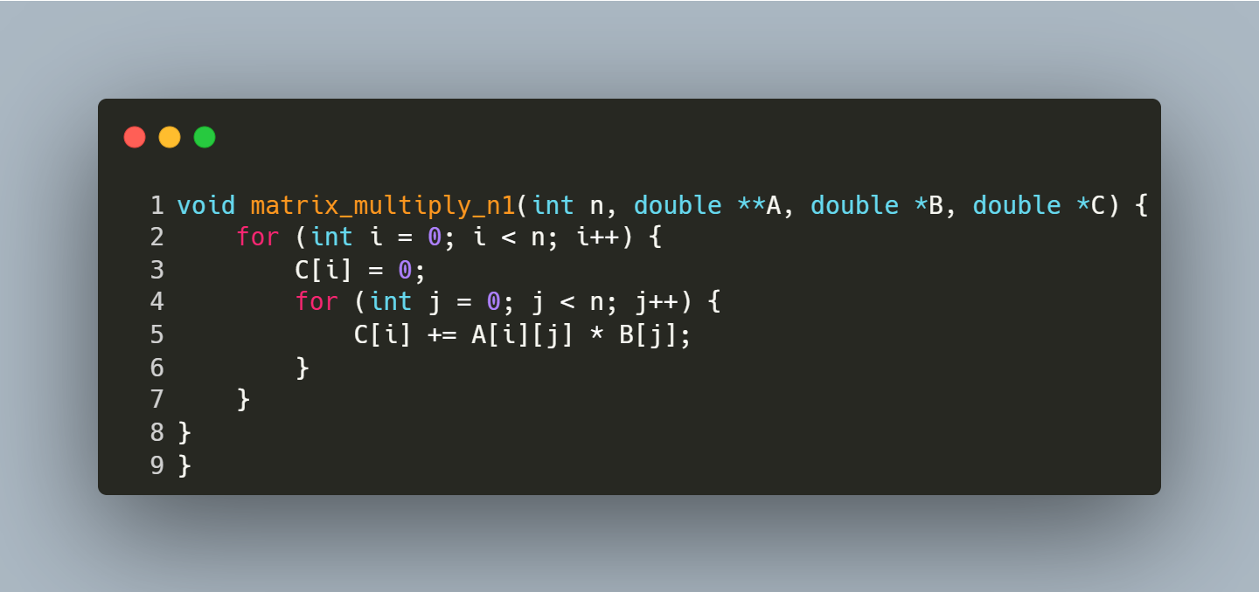
Step-by-Step Explanation
- Initialization:
  - The outer loop for (int i = 0; i < n; i++) iterates over each row of matrix A.
- Reset Result Vector:
  - C[i] = 0; initializes the i-th element of the result vector C to zero.
- Dot Product Calculation:
  - The inner loop for (int j = 0; j < n; j++) computes the dot product of the i-th row of A and the vector B:
    - C[i] += A[i][j] * B[j]; accumulates the product of the matrix element A[i][j] and vector element B[j].
- Result Storage:
  - After the inner loop completes, C[i] holds the dot product result for the i-th row.

Function : QR Factorization for Solving Linear Systems

Purpose: This function solves a linear system Ax = b using QR factorization. It decomposes matrix A into Q (orthonormal) and R (upper triangular), then solves Rx = Qᵀb via backward substitution.
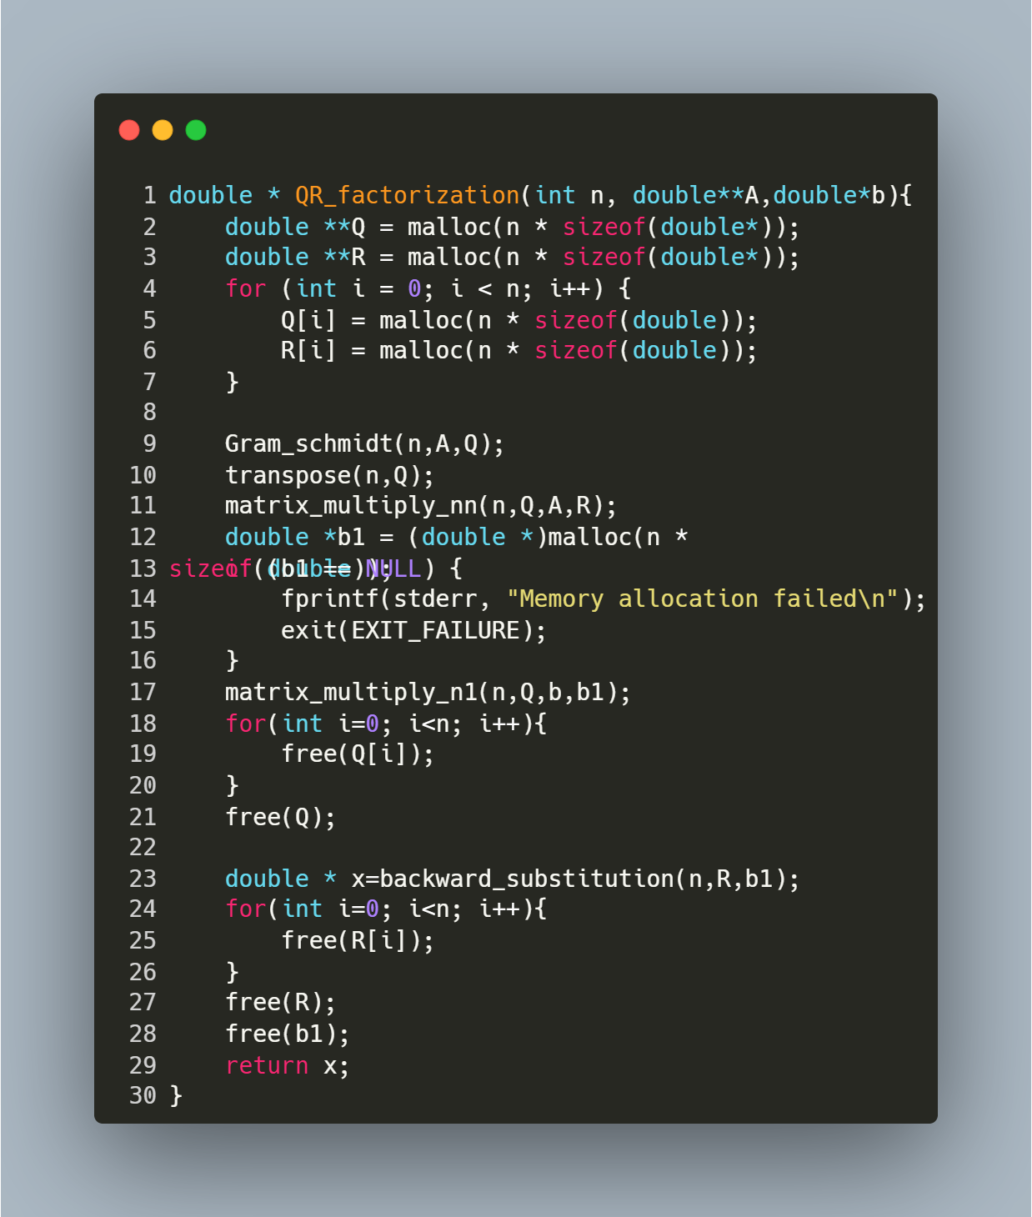
Step-by-Step Explanation
- Memory Allocation:
  - Allocates memory for matrices Q (orthonormal) and R (upper triangular).
- Gram-Schmidt Process:
  - Gram_schmidt(n, A, Q) transforms A into Q with orthonormal columns.
- Transpose Q:
  - transpose(n, Q) converts Q from column-orthonormal to row-orthonormal (effectively computing Qᵀ).
- Compute R:
  - matrix_multiply_nn(n, Q, A, R) calculates R = Qᵀ * A.
- Transform b:
  - matrix_multiply_n1(n, Q, b, b1) computes b1 = Qᵀ * b.
- Solve for x:
  - backward_substitution(n, R, b1) solves Rx = b1 to find the solution vector x.
- Memory Cleanup:
  - Frees Q, R, and b1 to prevent leaks.

function : Reading Matrix and Vector Input from a File

Purpose: This function reads a square matrix A of size n x n and a vector b of size n from a file named "inputs.txt". It ensures proper error handling for file operations and input parsing.
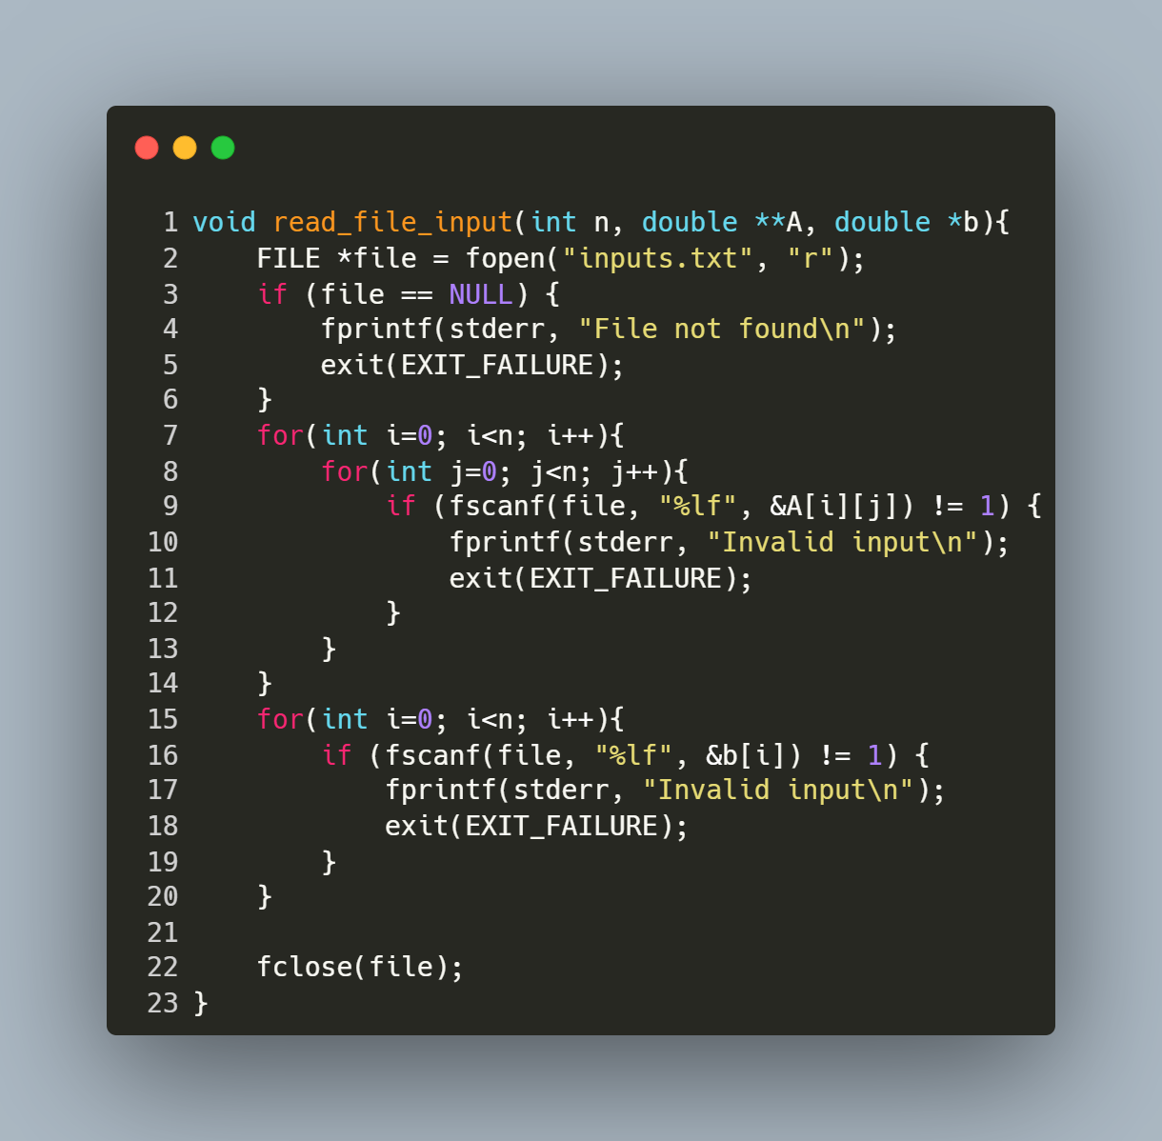
Step-by-Step Explanation
- Open File:
  - FILE *file = fopen("inputs.txt", "r"); opens the file "inputs.txt" in read mode.
  - If the file cannot be opened (e.g., it doesn't exist), the program prints an error message ("File not found") and exits.
- Read Matrix Elements:
  - The nested loop for (int i = 0; i < n; i++) { for (int j = 0; j < n; j++) { ... } } iterates through each row (i) and column (j) of matrix A.
  - fscanf(file, "%lf", &A[i][j]) reads a floating-point number from the file and stores it in the corresponding position in A.
  - If the input is invalid or missing, the program prints "Invalid input" and exits.
- Read Vector Elements:
  - The loop for (int i = 0; i < n; i++) { ... } iterates through each element of vector b.
  - fscanf(file, "%lf", &b[i]) reads a floating-point number from the file and stores it in the corresponding position in b.
  - Similar error handling ensures that invalid or missing input causes the program to terminate with an error message.
- Close File:
  - fclose(file); closes the file after all data has been read to release system resources.

FUNCTION: Main Program for Solving Linear Systems via QR Factorization

Purpose: This program solves a linear system Ax = b using QR factorization. It reads matrix A and vector b from a file, computes the solution x, prints the result, and measures the execution time of the QR factorization process.
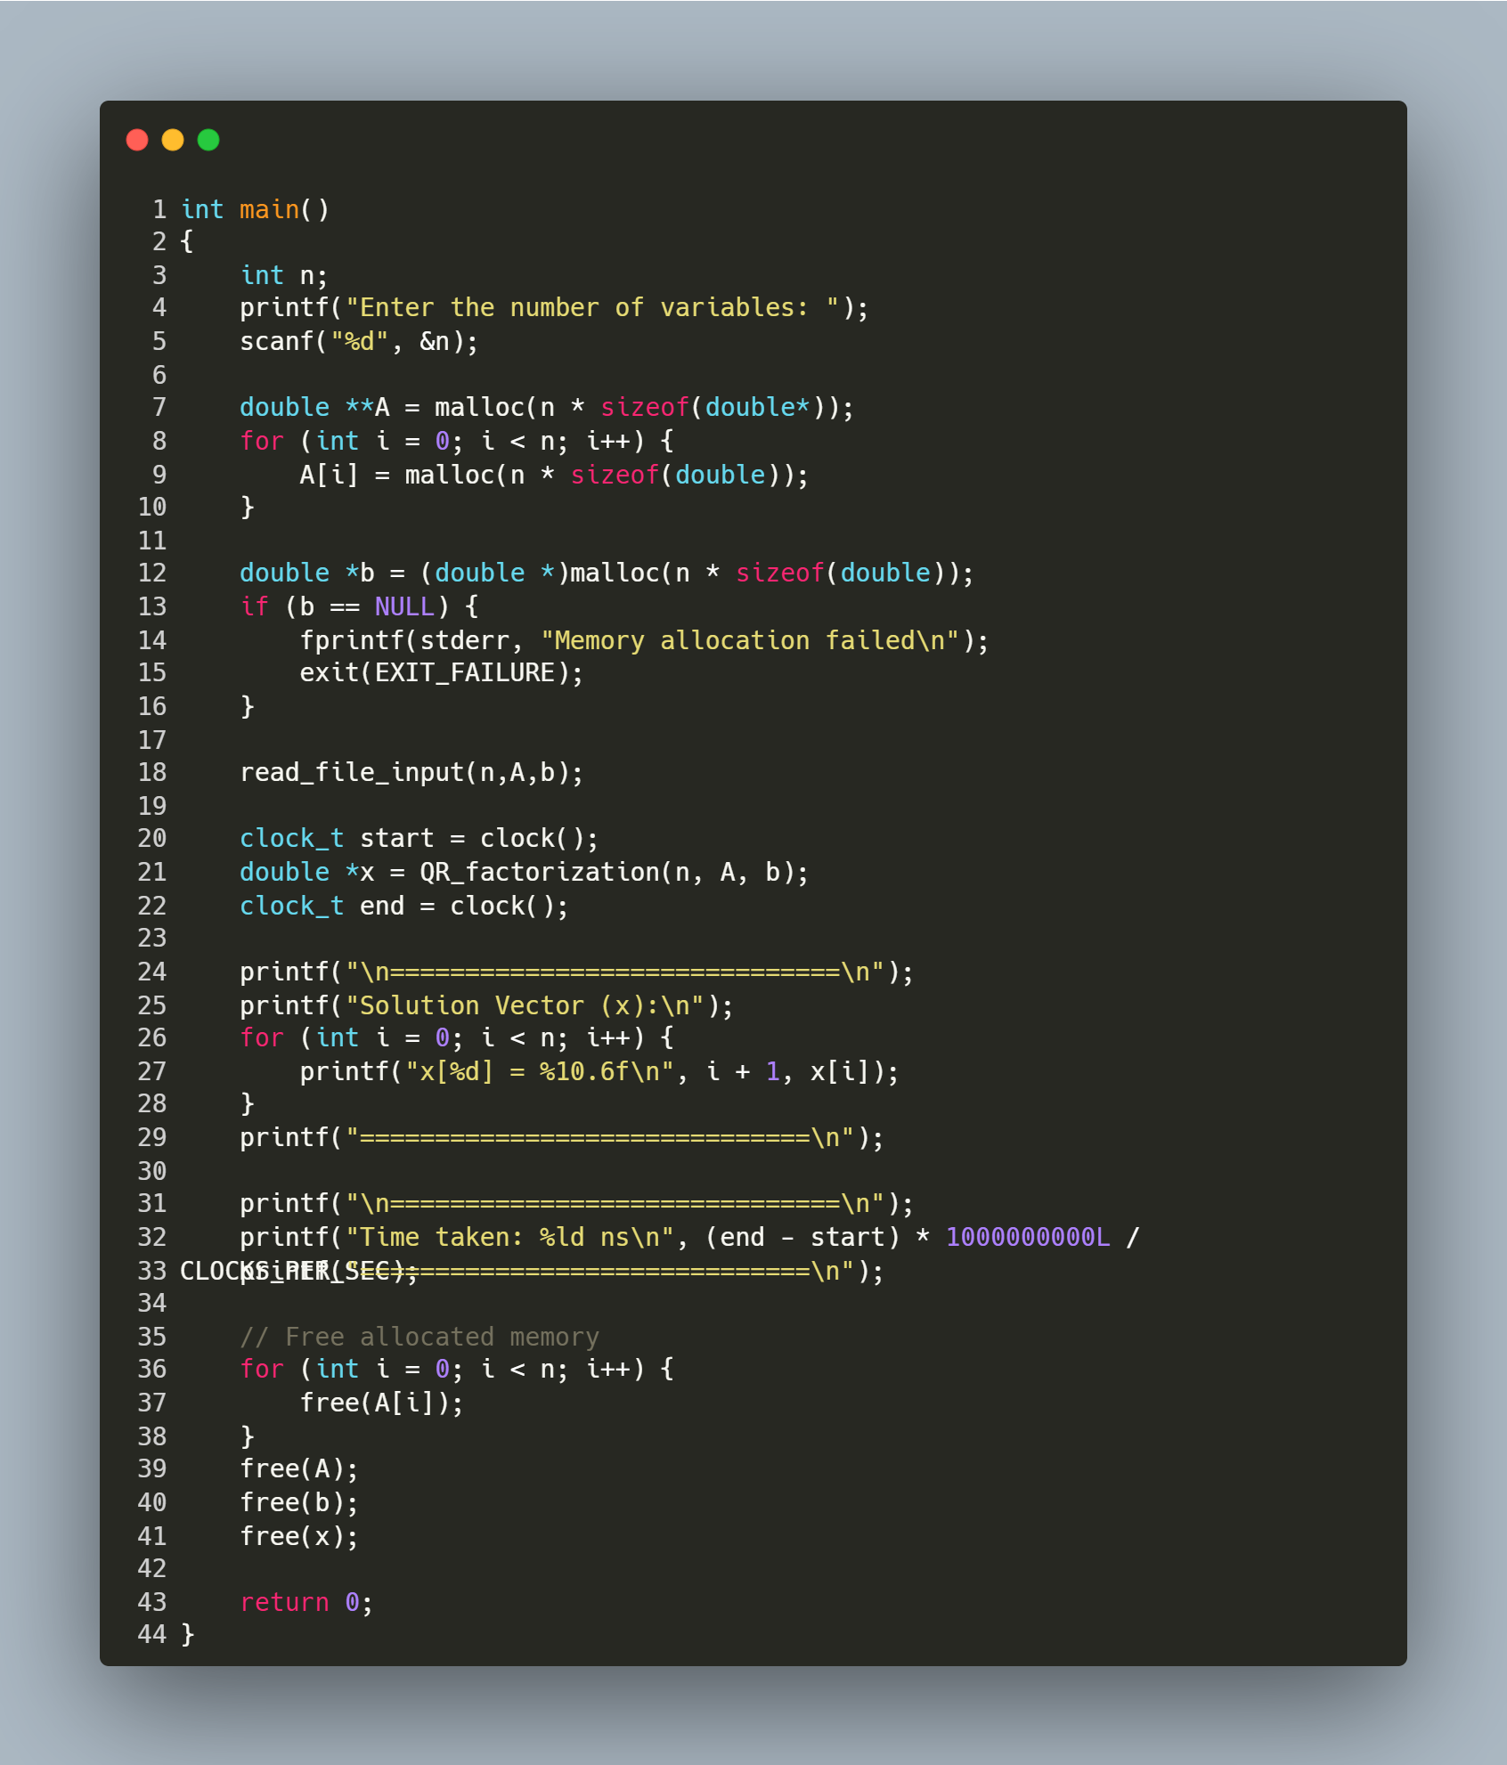
Step-by-Step Explanation
- User Input:
  - Prompts the user to enter the number of variables (n).
- Memory Allocation:
  - Allocates memory for:
    - A (n x n matrix) using nested malloc calls.
    - b (vector of size n).
  - Checks for allocation failure in b and exits if memory is unavailable.
- Read Input File:
  - Calls read_file_input(n, A, b) to populate A and b from "inputs.txt".
- QR Factorization & Timing:
  - clock() records the start time.
  - QR_factorization(n, A, b) computes the solution vector x.
  - clock() records the end time.
- Print Results:
  - Displays the solution vector x with 6 decimal places.
  - Calculates and prints the execution time in nanoseconds.
- Memory Cleanup:
  - Frees all dynamically allocated memory for A, b, and x to prevent leaks.
- Key note:
  - The clock() function used to measure execution time in this program works reliably when running in Windows Subsystem for Linux (WSL) via VS Code. However, if you run the same code in a terminal-based VS Code setup (outside WSL), the behaviour of clock() may vary or provide poor precision due to platform-specific differences in how the function is implemented.
  - To ensure accurate timing, it is recommended to use this program within a WSL-based VS Code environment.

